CHEF BRIAN KIDDIE
CERTIFIED EXECUTIVE CHEF

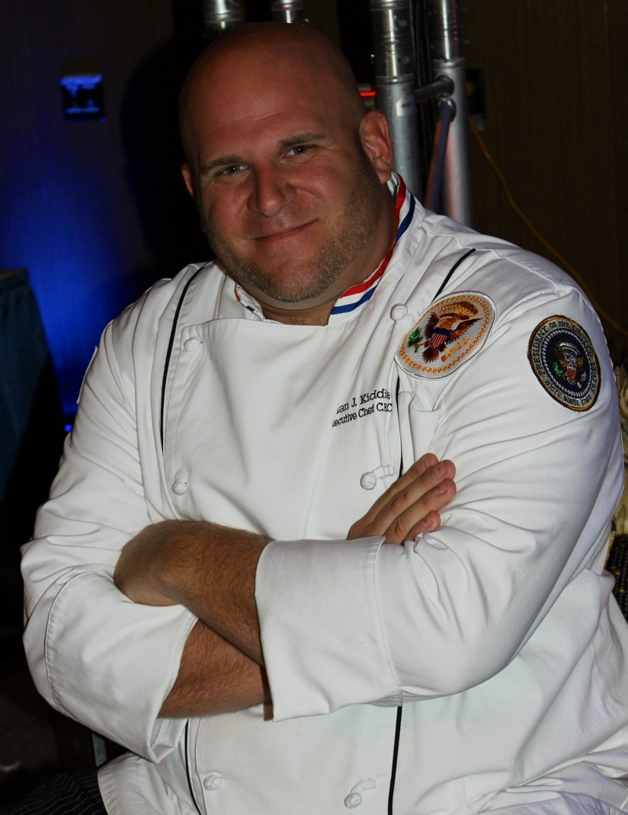

Chef Brian J. Kiddie was raised on the New Jersey shore where he was influenced on a day to day basis by the vast culinary industry. After completing culinary school and an internship in Europe, under Master Chef Hans Mueller, Chef Brian J. Kiddie was given the honor to work as a chef in the residence of The White House in Washington D.C., under the direction of Executive Chef Walter Scheib.

Chef Brian J. Kiddies’ time spent at The White House residence kitchen consisted of cooking for many foreign dignitaries and cabinet members such as Madeline Albright, Donald Rumsfeld and Tony Blair. But mostly Chef prepared meals for the first families of President William “Bill” Clinton and President George W. Bush on a daily basis stateside and abroad. The kitchens of The White House residence were always a new adventure and culinary challenge due to the vast international cuisines that were being put together for Head of State dinners and foreign guests.

A few months following September 11, 2001 Chef Brian J. Kiddie moved back to New Jersey. He then went back to manning the helm as the Executive Chef at different prestigious restaurants. Chef also continues to participate in regional charity events such as the Breeders Cup, where he cooked alongside celebrity chef David Burke preparing specialty dishes for the V.I.P. crowds. Chef also has had the privilege to prepare dinners for high profile clients such as, Bo Derek, Bruce Springsteen and Joe Klecko. Brian strives to help educate young culinary students during his daily routine in his kitchens as well as through the American Culinary Federation. Chef Brian J. Kiddie is currently the Executive Chef at the American Hotel in Monmouth County N.J. where he continues to dish up daily culinary delights.

